UP IAS officer wins Gold in Asian Para-Badminton Championships
Hindustan Times, Varanasi :Nov 28, 2016

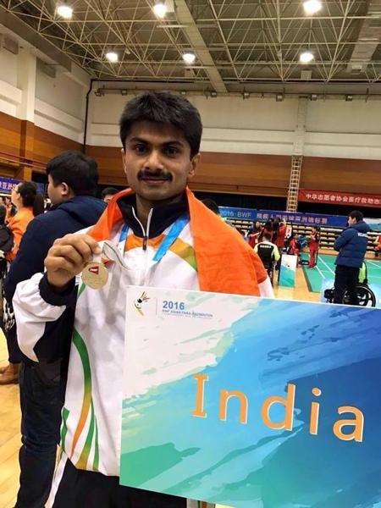
IAS officer Suhas LY struck Gold in the Asian Para-Badminton Championships that was held in Beijing by defeating Indonesian player Harry Susanto in straight sets by 21-4 and 21-11.
Suhas, who is posted as the Azamgarh District Magistrate, got a wildcard entry to the Championships and ensured his seat in the finals by winning six consecutive matches.
The 2007 batch officer defeated Wang Hwan Sing of Korea in the Semifinals.
“It is a wonderful feeling. I can’t explain in words. We woke up to the Gold news. I offered special prayers for his victory. His hard work and dedication to Badminton materialised his dream to win the Gold,” his wife, Ritu Suhas, told Hindustan Times over the phone.
Suhas was part of the 26-member Indian Team that landed in the Chinese capital to participate in the tournament. Besides Suhas, Abu Hubaida was another member from UP in the Team.
National Paralympics Committee of China hosted the Championship, which took place between November 22 and November 27, in which players from India, Sri Lanka, Indonesia, South Korea and several other Countries participated.
----------------------------------

